1.Use the Windows command prompt to run the command ipconfig /all on your computer and take a screenshot of the output. Identify and write down your IPv4 address, subnet mask, default gateway, and DNS servers as shown in the result.
->IPv4 Address. . . . . . . . . . . : 172.29.208.1(Preferred)
Subnet Mask . . . . . . . . . . . : 255.255.240.0
Default Gateway . . . . . . . . . :
DNS Servers . . . . . . . . . . . : 192.168.0.1
2.Simulate a network connectivity issue by disconnecting your Wi-Fi or Ethernet cable, then use the ping command to check connectivity to www.google.com. Reconnect and repeat the ping. Write a short note on the difference in results and what each status means.
->Before Reconnecting (Wi-Fi Off)
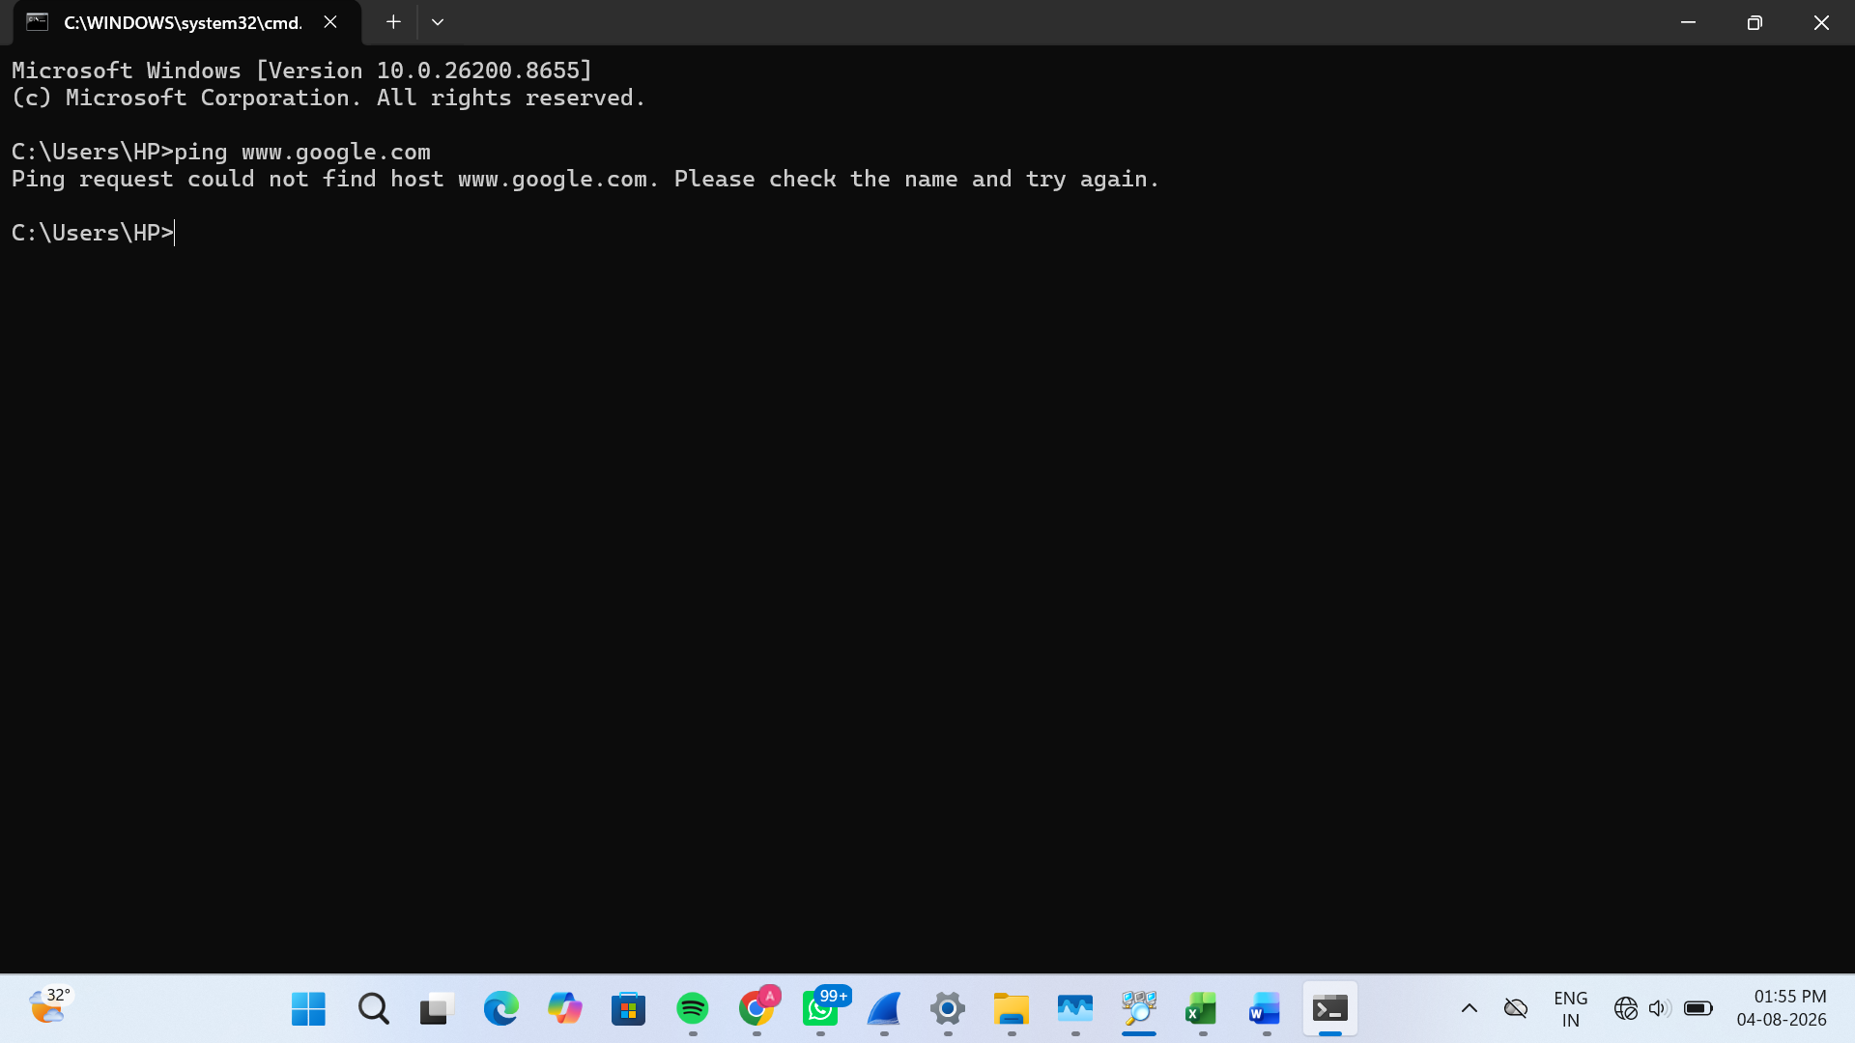
Meaning:
The computer could not reach www.google.com because there was no network connection.
After Reconnecting (Wi-Fi On)
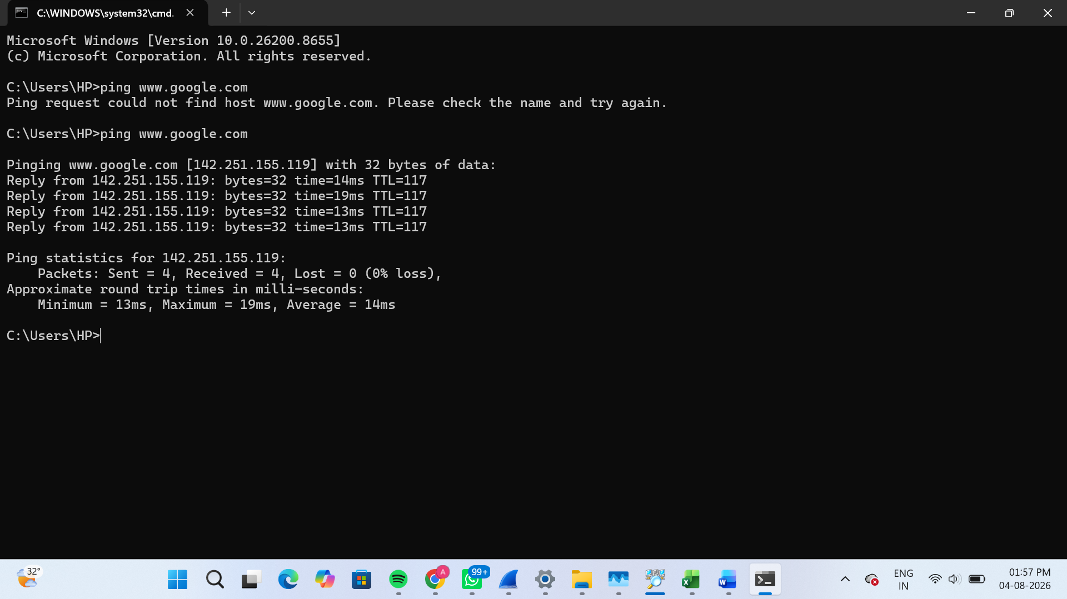
Meaning:
The computer successfully connected to www.google.com and received a response from the server.

3.Open Task Manager or Resource Monitor on your system and monitor network usage for 5 minutes while streaming a YouTube video. Record the peak network usage value and note which process used the most bandwidth during this time.
->Observation:
While streaming a YouTube video for 5 minutes, chrome.exe used the highest network bandwidth because it continuously downloaded video data. The network usage increased during video streaming.
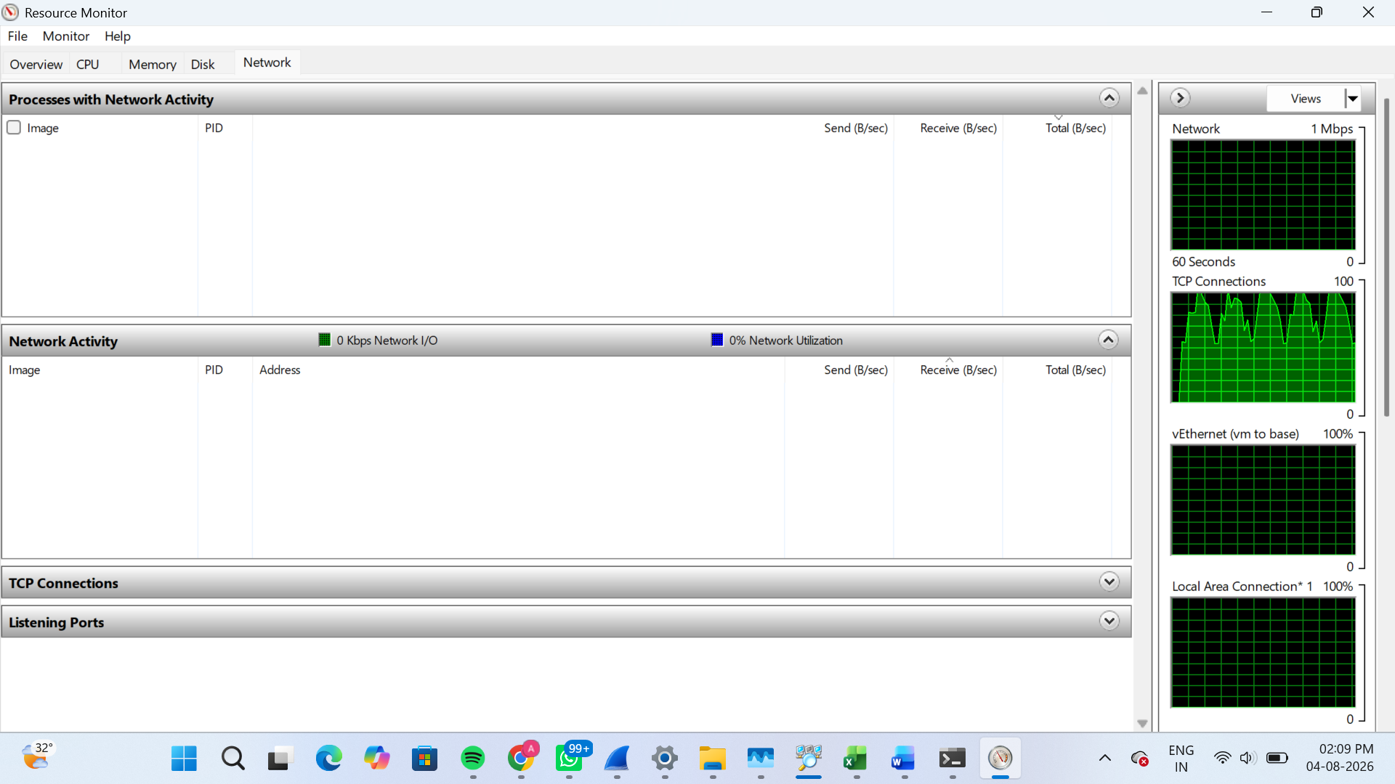
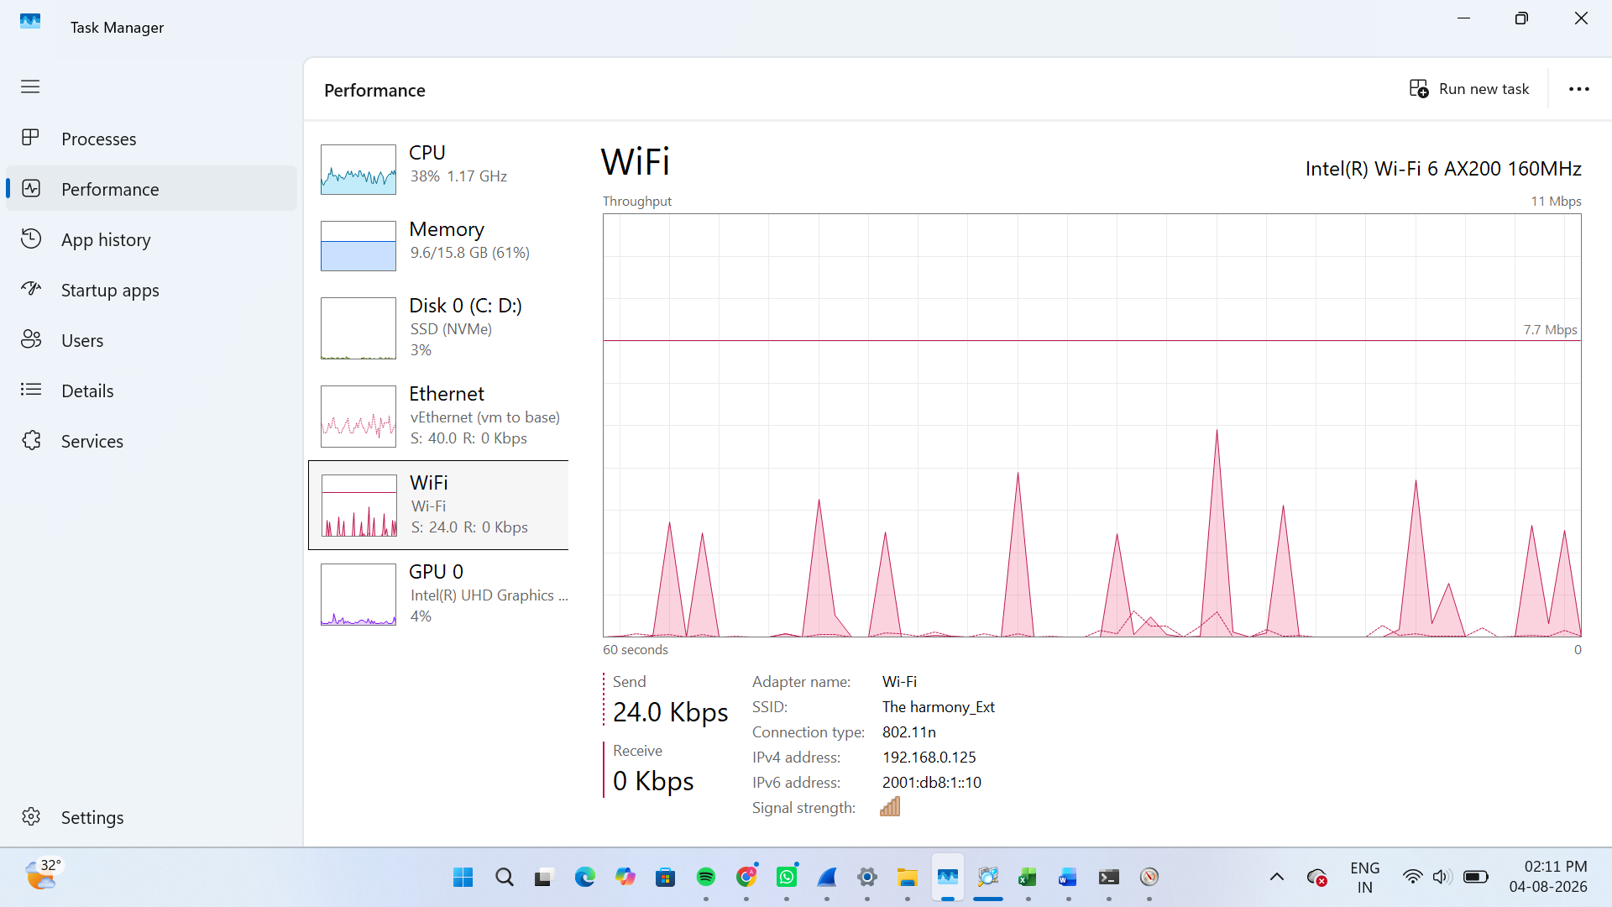
4.Download and install Wireshark (or use an online packet capture demo if installation is not possible). Capture at least 30 seconds of network traffic while browsing Flipkart or Instagram Web, then filter the packets to show only HTTP or HTTPS traffic. List 3 types of information you can see in these filtered packets.<br><br><em><strong>Hint:</strong> Use the filter bar in Wireshark and try http or https as the filter keyword.</em>
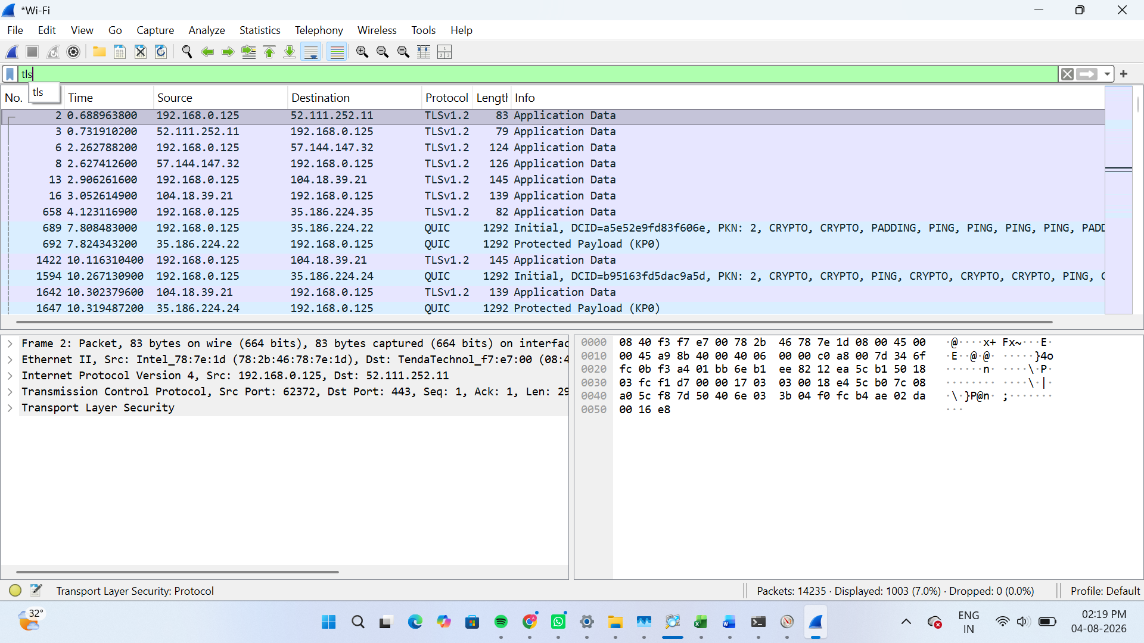
Website: Flipkart
Capture Duration: 30 seconds
Filter Used: tls
Three Types of Information Visible
- Source IP Address – The IP address of the sender.
- Destination IP Address – The IP address of the receiver.
- Protocol / Packet Details – The protocol used (TLS/HTTPS) and packet information such as packet length and time.
Conclusion
The filtered packets showed secure web communication between my computer and the website. I was able to view source and destination IP addresses, the protocol, and packet details.

5.Imagine your friend is complaining about slow internet while gaming online. Use ChatGPT or any AI tool to generate a troubleshooting checklist (at least 5 points) for optimizing home network speed and reliability. Paste the AI's response and highlight one suggestion you would try first.
AI-Generated Troubleshooting Checklist for Slow Internet While Gaming
- Restart your modem and Wi-Fi router to refresh the network connection.
- Use a wired Ethernet connection instead of Wi-Fi for lower latency and a more stable connection.
- Close unnecessary apps and downloads that use internet bandwidth in the background.
- Move closer to the Wi-Fi router or reduce obstacles between your device and the router to improve signal strength.
- Update your router firmware and network drivers to ensure the best performance and security.
Suggestion I Would Try First (Highlight This)
I would first restart my modem and Wi-Fi router because it is a quick and simple step that often fixes slow internet and connection issues.

